# **Project Proposal**

Human-Factors and Ergonomics

Class session number: 02

Team number: 05

Team members: 이승유, 유희찬, 천효정, 홍주원

### ­­

## **Topic**



To improve SMART CAMPUS application structure and develop it to replace HISNET mobile version

## **Background**

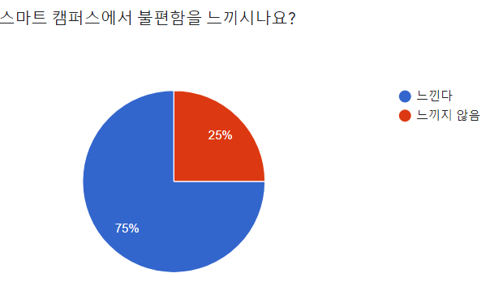 This project aims to solve the main problems that actual smart campus users are experiencing. According to the preliminary survey**, 75% of Smart Campus** users felt **inconvenient with Smart Campus**, and the reasons for the inconvenience were **slow loading speed of the screen**, frequent **login errors** and **server collisions, QR tagging not being on the main screen**, **complicated menu configuration**, and **access multiple functions**.

### **<Problem #1>**

First, when the smart campus app is opened, the most used feature: QR tagging for attendance is not on the main screen. In addition, it is possible to find a problem that the area of the banner disposed on the main screen is too large compared to its usefulness.

### **<Problem #2>**

The second problem approach focused on the menu screen. There are too many functions on the menu screen to be identified when looking for a specific menu.

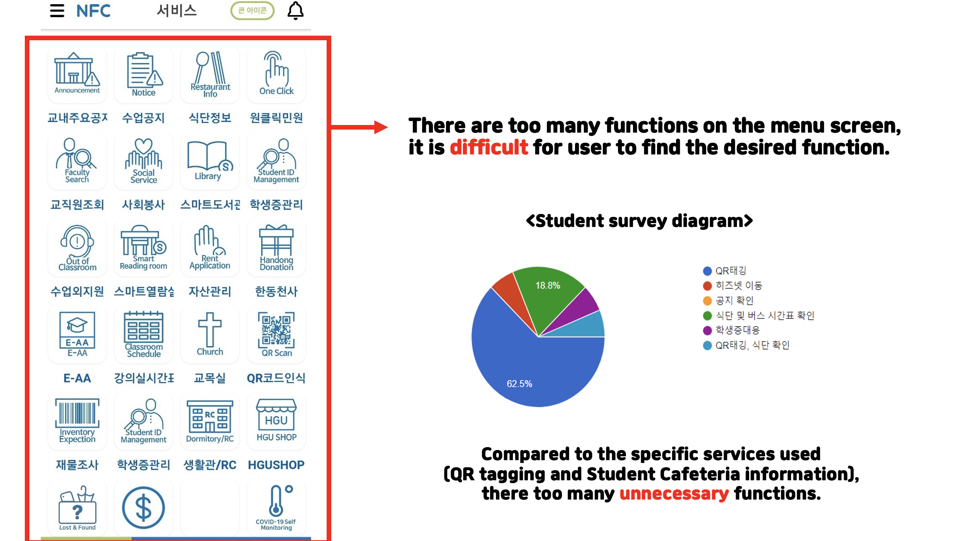

### **<Problem #3>**

The third problem is that the white screen causes eye fatigue. There is no dark theme setting that exists on the smart campus itself, and when the dark mode of the mobile phone is applied, it is not compatible, therefore it is not user-friendly in visuality

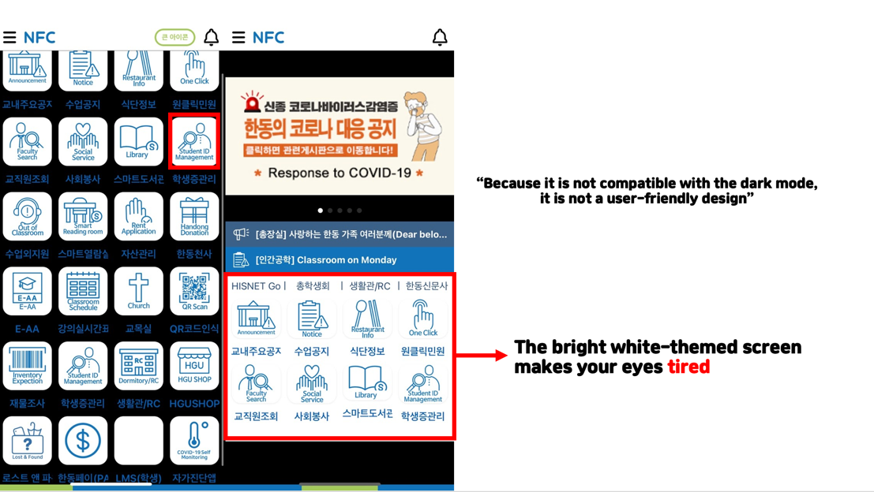

## **Plan for prototyping**

**<QUICK MENU>**

### **Setting personal quick menu “My Favorite Menu”**

**Methods**: Users can save their own favorite menus in the quick menu slot  
**Effects**: Increase the convenience, every user can find what they want without any distraction

### **Organizing the placement of the Start Screen**

**Methods**: Remove unnecessary banners and place the commonly used dormitory QR code on the main screen  
**Effects**: Make it simpler and easier to use for the users. Therefore, the users can see the key functions that they need the most on the main screen

### **Classification of functions**

**Methods**: Classify the functions by categories on the menu screen  
**Effects**: Increase the efficiency, reduce time of working process when the user find a particular menu

### **Improvement of Dark mode**

**Method**: Make dark mode theme that makes the screen completely dark  
**Effects**: Eliminate the eye fatigue

### **Notification for New announcement**

**Methods**: When a new class notice or major notice is uploaded, a notification push is displayed on the mobile phone.  
**Effects**: Help users not to miss any notification.

## **Plan for an experiment for usability evaluation**

### **Participant**

**Target:** Students who use Smart Campus app  
We will gather participants using SNS.  
6 students (two students for each grade 1, 2, and 3)

### **Purpose**

The purpose of this project is to find a problem with an existing Smart Campus app and check whether the problem has been solved when Smart Campus is replaced with the new version.

### **Composition of the experimental session.**

**<Session 1. Check attendance through QR scan menu.>**

Situation: When I checked the time, it is 09:59, one minute before the class starts. Unless you quickly take out the QR code scanner on Smart Campus and tag it, you will be late for attendance

Task: Please check QR code by using QR code scanner on the smart campus app.

**<Session 2. Find the specific menu>**

Situation: It is difficult to find the menu that I want to use, because there are large amount number of menus and the menu screen is complicated.

Task: Please find the menu that the experimental guide requested.

**<Session 3. Open the smart library and check what textbooks were  
needed as written in the class schedule.>**

Situation: I opened a smart library tap to find a book that I have to write a book review about as an assignment from some class, but I do not remember the title of the textbook.

Task: Please display the class syllabus tab while the smart library tab is opened and check the supplementary materials.

### **Equipment**

Eye tracker, Cell phone, Camera, Survey paper, Introduction of the experiment.

### **Variables**

**Quantitative**: How much you touched and how quickly you found it  
**Qualitative:** How much convenience did the user feel and where he focused on (with. eye tracker and interview)

### **Method**

**Compare the prototype to the existing smart campus**  
- Comparison of the number of touches and time while users are doing the same task  
Get feedbacks from experiment using an eye tracker.

### **Process**

## **Schedule**

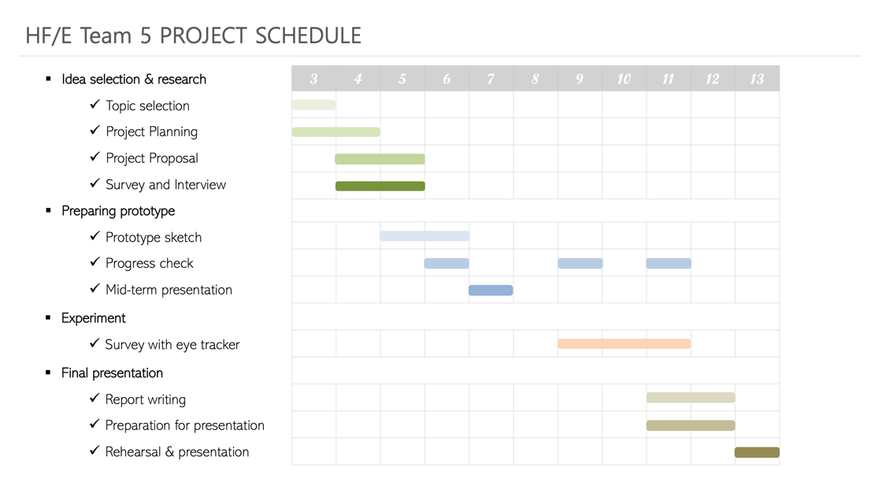

## **Expected outputs**

* **Improved task performance** – Reorganization of Menu, Category
* **Improved physical discomfort** – Dark Mode
* **Improved inconvenience and satisfaction**
* **Identification of potential sources for supporting follow-up activities**